

MATHEMATICS
YEAR 08

Investigation 3 – Angles, Parallel Lines and Transformations
Semester 2 2015



Information for Students

Working time: 70 minutes
Marks available: 56 marks

- (2 marks)
Draw two sets of parallel lines below, labelled set A and set B.

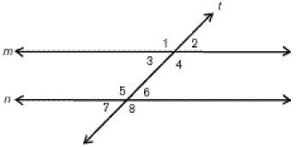
- (9 marks)
Consider the lines below.

- What do we know about the gradients (slopes) of lines m and n? [1]

- What is the technical name of line t, which cuts lines m and n? [1]

- What is the term for the relationship between angles 3 and 6? [1]

- What is the term for the relationship between angles 4 and 6? [1]

- What is the term for the relationship between angles 2 and 6? [1]

- If angle 5 is 120°, how many degrees are in angle 3? [2]

- If angle 7 is 40°, how many degrees are in angle 4? [2]

- (8 marks)
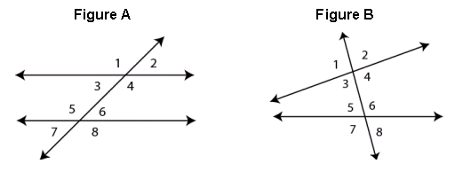

END OF INVESTIGATION

In BOTH figure A and figure B, angle 1 is supplementary to angle 2.
Angle 4 is also supplementary to angle 2.
Supplementary angles always add up to a certain number of degrees, let us call this x°

- How many degrees are in x°? (Consider how many degrees there are in a straight line.) [1]

- In figure B, if angle 6 is 140°, how many degrees are in angle 8? [1]

In figure A, angles 1 and 4 are vertically opposite. So are angles 6 and 7.

- If angle 1 is 110°, how many degrees are in angle 2? [2]
What do you then know about how many degrees are in 4?

- If angle 6 is 30°, how many degrees is angle 8? How about angle 7? [2]

- Comparing pairs of angles 1 and 4 and angles 6 and 7 in part a) and b), if we know one angle, what do you think we know about the other vertically opposite one? [2]

- (7 marks)

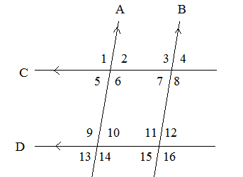

A company wants to design a mosaic using parallelograms. They decide to use the pattern above, but they need to know all the angles involved for the designer. The only piece of information they have is that angle 1 is 100°. Using your knowledge of parallel lines cut by transversals, determine angles 2-16 and write your answers below:
Number | Angle | Number | Angle | Number | Angle
2 |  | 7 |  | 12
3 |  | 8 |  | 13
4 |  | 9 |  | 14
5 |  | 10 |  | 15
6 |  | 11 |  | 16

5. (7 marks)
- State the (x,y) coordinates of the top-left hand corner of the shape. [1]

- Translate the shape by [7,1] and label the shape A. [2]
- Translate A by [-8, -7] and label the new shape B. [2]
y
x
(x,y)
(5,1)
- Describe a single translation that could take shape B to shape A. [2]

- (8 marks)

- State the (x,y) coordinates of the bottom-left hand corner of the shape. [1]

- Reflect the shape in the y-axis, and label it A. [2]
- Reflect shape A in the line y = -2 (draw this line to help) and label it B. [2]
- Reflect the original shape in the line x-axis and label it C. [2]
y
(4,2)
x

- Describe how the x and y coordinates of any point on the outside of the shape (e.g. (4,2)) changed when reflecting the original shape in the x-axis [1]

- (8 marks)

- Fully describe the single transformation which took shape A to shape A’. [2]
A’
A
(4,1)
- Fully describe the single transformation which would return shape A’ to A. [2]

Rotation
- Rotate the shape 270° clockwise about the origin and label it A. [2]
- Rotate the original shape 180° about the point (3,3) and label it B. [2]
(5,2)

- (7 marks)

- Describe fully the transformation from shape A to the shape B. [1]

- Describe fully the transformation that takes shape B to shape C. [1]

- What single transformation could take shape C back to shape A? [2]

(4,2)
C
B
A
- Translate shape A by [-2, -3] and label it A’. [1]

- Reflect A’ in the y-axis and label it A’’. [1]

- Rotate A’’ 180 degrees about the origin (0,0) and label it A’’’. [1]

End of Investigation

